Title of Paper Less Than 15 Words (Times New Roman Bold 12 pt)

First author¹, Second author², Third author³ (Times New Roman bold 10 pt)

¹First author affiliation, University/Institute, City; First author Email address (Times New Roman 10 pt)
²Second author affiliation, University/Institute, City; Second author Email address (Times New Roman 10 pt)
³Third author affiliation, University/Institute, City; Third author Email address (Times New Roman 10 pt)

Abstract
Papers dealing with any aspect of mechanical engineering from fundamental sciences to applications in engineering systems and nature are solicited. The abstract should include definition of the problem, assumptions, method of solution, summary of important results and at least in 150 and maximum in 250 words. The abstract should clearly state the objective, results and the conclusion of the work. The abstract appears before the keywords.

Keywords: first keyword, second keyword, ... (At least three and maximum five keywords)

Introduction
These guidelines serve as a template for Microsoft Word. Please carefully follow the instructions provided in this format to ensure legibility and uniformity.
When you open this document, select "Print Layout" from the "View" menu, which allows you to see the two-column format and the footnotes. You may then type over sections by using cut and paste into it, and/or use the markup styles. Please note that your papers should have 4 to 6 pages.

Elements of a Paper
The basic elements of a paper are listed below in the order in which they should appear:
- Identification number of paper
- The title of paper
- Authors' names and affiliations
- Abstract
- Keywords
- Introduction
- The main body of paper (including figures and tables)
- Results and discussions
- Conclusions
- Acknowledgement ( if applicable)
- Nomenclatures
- References
- Appendix (if applicable)

Paper Preparation
Papers must be prepared in the format of MSWord software, (ISME-XXXX.doc), and uploaded from the conference web site (http://conference.isme.ir/) in both PDF and DOC formats.
Papers may be written in English or Persian, and they will be presented in the language written.
The paper size for manuscripts is A4 with 20 mm margins from all sides and it should be divided into two columns with 8 mm space after authors' affiliations.
For English papers, the fonts for different parts of the paper are in Times New Roman as follows:
- Title: 12 pt bold (centered)
- Author(s): 10 pt bold (centered)
- Affiliations: 10 pt (centered)
- Keywords: 10 pt
- Section Headings: 10 pt bold
- Subsection Headings: 10 pt
- Body of manuscript: 10 pt
- Caption of tables and figures: 9 pt
Conference header and Identification number of paper should be in Arial, 9pt and 11pt, respectively. Furthermore, the section headings will start from the far left and use single spacing paragraph format with no space between the section headings and the paragraph following it. The first line of the first paragraph of each section is not indented, but the others are indented by 5 mm. Put one space between the texts of main sections. Paper must have page numbers.

Submission of Papers to the Conference Secretariat
The submitted papers to the conference should be in both the word format and PDF. The only way to send the papers is through the conference web-site. After uploading, a confirmation letter will be sent to the corresponding author and a notification letter will be sent to all other authors.
The papers which are accepted with comments, the authors should modify the paper according to the referees' comments and re-send it back to the conference together with an explanation letter. If papers are not prepared according to the referees and scientific committee comments or this guideline, they will be withdrawn from the conference program.

Footnotes
Footnotes must be formatted as 8pt Times New Roman and should be numbered consecutively using superscript numbers. The footnotes must be positioned flush left at the bottom of the column/page in which the first reference appears and must be spaced at one line from the text. This is an example of a footnote.

System of Units
SI system of units is deemed to be used. If necessary, use the equivalent value in the other system of units in brackets after the SI system of units.
Equations
Equations should be in text format, not as pictures. Equations start from the far left of the column and numbered consecutively. The equation numbers must be bracketed and placed opposite to the equation on the far right of the line in that column.
(1)

Tables
Tables must be numbered and the title of the table must be placed on the top of the table with the footnotes on the bottom. Tables must appear where (or as close as to) they are first mentioned in the text. They must be referred in the text as "Table 1".

Table 1. An example of a table.
Number | Area (m²)
1
2
3

Figures and Photographs
Figures must be numbered and the caption of the figure must come at the bottom of the figure. All the legends and the numerical values on the axes of the curves must be clear and readable. Figures must appear where (or as close as to) they are first mentioned in the text. They must be referred in the text as "Figure 1". Photographs must be original and are treated similar to figures. Leave one space between the Table/Figure and the text following it.

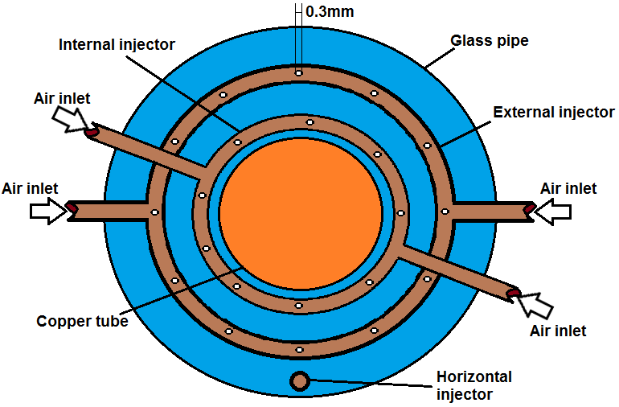
Figure 1. An example of a figure

Results and Discussion
Results of the work and discussions are presented here.

Conclusions
Main conclusions of the paper must be put here.

Acknowledgement
Acknowledgements should appear here, if necessary.

Nomenclature
The list of symbols comes after the acknowledgment and before references. The English symbols come first followed by the Greek symbols. Both must be typed in alphabetical order and separated.

Modulus of elasticity
Stiffness
Acoustical pressure
Greek symbols
Flow resistivity
Shear stress

References
References must be numbered and be listed in the list of references in the order that they are referred to in the text. The reference numbers must be put in the squared bracket for example, [1]. The complete details of the references will appear in the list of references. For journal papers, books and conferences papers use the following formats:

- Author, A., Author, B., and Author, C., 1994. “Article Title”. Journal Name, 1(5), May, pp. 1–3.
- Author, A., 1986. Book Name. Publisher Name, Address.
- Booklet, A., 1994. Booklet title. On the WWW, at http://www.abc.edu,May. PDF file.
- In book, A., ed., 1991. Book title, 1st ed., Vol. 2 of Series Title. Publisher Name, Publisher address, Chap. 1, pp. 1– 3. See also URL http://www.abc.edu.
- In collection, A., 1991. “Article title”. In Collection Title, A. Editor, ed., 3rd ed., Vol. 2 of Series title. Publisher Name, Publisher address, May, Chapter 1, pp. 1–3. See also URL http://www.abc.edu.
- In proceedings, A., 1991. “Article title”. In Proceedings Title, A. Editor and B. Editor, eds., Vol. 1 of Series name, Organization Name, Publisher Name, pp. 1–3. Paper number 1234.
- ASME, 2003. ASME Manual MS-4, An ASME Paper, latest ed. The American Society of Mechanical Engineers, New York. See also URL http://www.asme.org/pubs/MS4.html.
- Masters thesis, A., 2003. “Thesis Title”. MS Thesis, University of Higher Education, Cambridge, MA, May. See also URL http://www.abc.edu.
- Misc, A., 2003. Miscellaneous Title. On the WWW, May. URL http://www.abc.edu.
- PhD thesis, A., 2003. “Thesis Title”. PhD Thesis, University of Higher Education, Cambridge, MA, May. See also URL http://www.abc.edu.
- Proceedings, A., ed., 1991. Volume Title, Vol. 1 of Proceedings Series, Organization Name, Publisher Name. See also URL http://www.abc.edu.
- Tech report, A., 2003. Tech report title. Progress report 1, University of Higher Education, Cambridge, MA, May. See also URL http://www.abc.edu.

↑ Please level both columns of the last page as far as possible.↑

An example of a footnote

